Application Note – AN002

Simulating physical layer faults

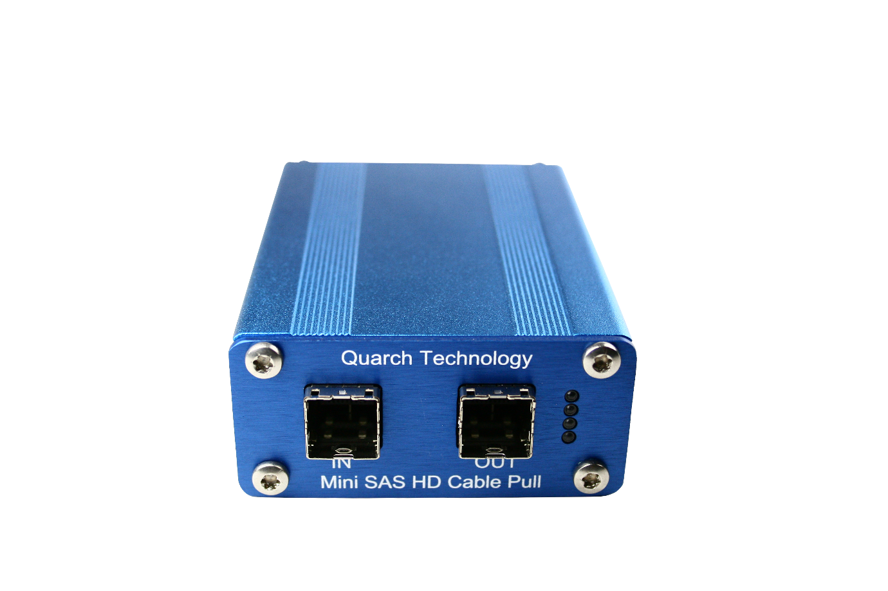

Contents

Contents 2
Introduction 4
The Test Requirements 4
Creating a simple data error 5
Fault one side of a pair 6
Fault Entire Lane 7
Random Disruption 8

Version | Date | Changes
1.0 | 2016 | First version
1.1 | 2016 | Bug fixes
1.2 | Feb 2018 | Updates for Python 3.x
1.3 | July 2021 | Updated old links
1.4 | Jan 2021 | Updated for NVMe and general improvements

Introduction

A customer requested information on creating a variety of different errors/faults on SAS cables, using the Quarch cable-pull modules.
This is a form of ‘physical layer fault injection’. Basically, we are simulating a range of different failures that can occur in the cables and connectors of a high-speed signal trace.
This is relevant to any communication bus, including PCIe/NVMe devices, USB, RJ-45 and much more.
In this application note, we show how to use the unique features of the Quarch modules to create these scenarios in a simple and automated fashion.
While this example will use a QTL2358 (Gen5 x16 AIC Breaker), it can be easily modified for any other Quarch breaker, simply by changing the names of the signals being controlled (SAS and PCIe naming standards are different so each breaker has its own naming convention which matches the industrial specification)

The Test Requirements

In this case, the customer asked if there was a way for them to simulate the data errors:
- Inject a simple data error (parity/framing error)
- Fault one side of a differential pair
- Fault entire lanes
- Create random disruption
Automation was also important to the customer, and they specified Python control as their preferred option.
You will need an appropriate Quarch breaker for the interface you wish to test. The list of signals controller by the breaker can be found with the command “HELP NAMES”. This will allow you to quickly modify the example python script included with this application note

Creating a simple data error
A single glitch can cause data corruption, framing errors, link-down or many similar errors depending on the length of the glitch and the exact time that the glitch is run. To time a glitch precisely within the data stream, you would require a module that supports external triggering so an analyser can be used to trigger the glitch at a precise point.
In this example, we have enabled a Glitch on all signals of Lane 0 with a Glitch length of 1ms and then run the Glitch Once command as below
SIGNAL:LANE0:GLITCH:ENABLE ON
GLITCH:SETUP 5us 200
RUN:GLITCH ONCE
When the final command is issued, all signals on Lane 0 (Tx and Rx pairs) will be disconnected for exactly 1mS.
If external triggering is used, the final command is not required, and the external trigger event would be used to begin the glitch, this allows for accurate placement of a physical layer fault, within a data stream.

Fault one side of a pair
Cutting one side of a differential pair will degrade the signal significantly, but the link may still work (though possibly with errors). This fault could occur with a bad cable or a bent pin.
In this case we created a fault on the +ve side of the Lane 0 Transmit pair: TX0_PL
By assigning the signal to source ‘0’ (the always OFF source), we disconnect it, simulating the fault. This could be done while traffic is running (simulating a fault during operation), or before the cable is ‘Plugged’ (simulating a faulty cable being inserted).
SIGnal:TX0_PL:SOURce 0
At this point, the signal is disconnected, you would normally query your device under test at this point, to see if the link is working, and if the fault has been detected.
SIGnal:TX0_PL:SOURce 1
Setting the signal back to source 1 reconnect the signal (source 1 is the default source for the signal on this module. Setting it to any timed source: 1-6 would have the same effect).

Fault Entire Lane
To create a fault on entire lane, we do exactly the same procedure, as we did with faulting one side of the pair, but we use the ‘laneX’ signal group, to affect every signal within the lane.
This can be used to see what happens when a lane fails. In some cases we may expect a fail over and continue with other lanes. For PCIe, faulting LANE0 will generally take down the entire link, even in the other lanes are working correctly.
SIGNAL:LANE0:SOURCE 0
Now the entire of lane 0 will be disconnected, you should be able to see this by querying your system, and ensuring the any appropriate fail-over or error reporting has worked correctly.
SIGNAL:LANE0:SOURCE 1
Reassigning the signal back to source 1 again will reconnect the lane. You should again check that the reconnection has been detected and is working fully.

Random Disruption
Random disruptions can be generated using the glitch system in PRBS mode. In the first example, we used a ‘Single’ glitch, but here we will be using the built in Pseudo Random Binary Sequence generator, to create a ‘random but repeatable’ series of glitches.
A PRBS is defined by a ratio:
1:4 – A glitch will be present for one quarter of the time (25% of the time)
1:64 – A glitch will be present for 1 64th of the time (~1.5% of the time)
As a ‘glitch’ is normally disrupting your device, the higher the ratio selected, the less impact there will be. A 1:4 glitch ratio on a 12G SAS lane will likely fail it completely, while a ratio of 1:65536 (0.0028% disruption) will likely work, but with errors.
PRBS generates a pseudo random sequence of glitches, where we can imagine time as a series of points based on the glitch length.
If the glitch length is 1mS, then time is split into 1mS regions
If the glitch length is 5mS, then time is split into 5mS regions
The number of regions that will be glitched is defined by the ratio. While the base glitch length is 1 or 5mS in this example, more than one glitch can occur in sequence, creating a single longer glitch. However the ratio will always be respected.
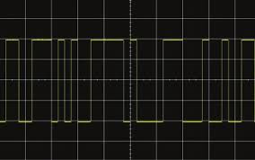
Here we see a 1:2 PRBS sequence, showing both short glitches, and ‘blocks’ of combined glitches.

As in the earlier example, we set a 1mS glitch on Lane 0:
SIGNAL:LANE0:GLITCH:ENABLE ON
GLITCH:SETUP 5us 200
PRBS ratios are set in powers of 2, from 1:2 up to 1:35536. This command sets the PRBS ratio to Glitch at an average rate of 1:16,384
GLITch:PRBS 16384
Unlike the single glitch example, PRBS glitches continue until stopped. To start the sequence we run:
RUN:GLITch PRBS
To stop the random disruption, we send the ‘stop’ command:
RUN:GLITch STOP

